Cosmic Collision Course
________________________________________________________________________

This Little Christian Went To The Market

In the matter of religious beliefs, the world today is filled with confusion. With over 400 Christian religions in the world, the most often asked question is "How can we know what is truth?" At the very hour of earth's history, when men need a clear understanding of truth, they are confused and bewildered, not knowing which way to turn. Does God have one True Church today? Is it possible to find truth? In the book of Revelation chapter 12, we have a marvellous prophetic outline of the sufferings and triumphs of God's church down through 2,000 years of time.

John 18:37,38 Pilate therefore said unto him, Art thou a king then Jesus answered, Thou sayest that I am a king. To this end was I born, and for this cause came I into the world, that I should bear witness unto the truth. EVERY ONE THAT IS OF THE TRUTH HEARETH MY VOICE. Pilate said unto him, WHAT IS TRUTH? And when he had said, this, he went out again unto the Jews, and saith unto them, I find in him no fault at all.

What is truth? Is the age long question of men's hearts. Jesus indicated that to follow His words would lead to truth.

John 7:17 IF ANY MAN WILL DO HIS WILL, HE SHALL KNOW OF THE DOCTRINE whether it be of God, or whether I speak of myself.

If one is in earnest about the things of God, then that one will find the truth.

Revelation 12:1 And there appeared a great wonder in heaven; A WOMAN CLOTHED WITH THE SUN, and THE MOON UNDER HER FEET, and UPON HER HEAD A CROWN OF TWELVE STARS.

The sun-clothed woman is a symbol of God’s true church. The Old Testament church was also symbolised by a pure woman.

Jeremiah 6:2 I HAVE LIKENED THE DAUGHTER OF ZION TO A COMELY AND DELICATE WOMAN.
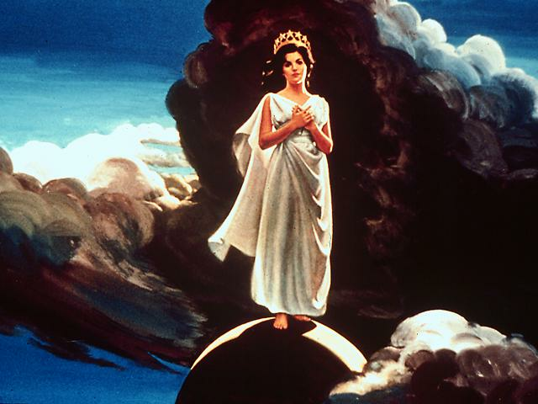
In 2 Corinthians 11:2, the New Testament church is also likened to a pure woman. Thus in this prophecy, the pure woman is the pure church. Notice she is clothed with the sun. This represents the glory surrounding the church, which is the gospel, God's people being clothed with the righteousness of Christ.

The moon under her feet represents the Old Testament reflection of the light of the gospel. The sacrifices and ceremonies were mere symbols of the real gospel brought by Christ. This is a fitting symbol, for as the moon reflects the light from the sun, so the Old Testament was a reflection of the New Testament. Then there is the crown of twelve stars, symbolising the triumph of the church.

The twelve stars once again represent God's church. The church in the Old Testament had twelve tribes. The church in the New Testament had twelve apostles. The church in the kingdom of heaven, according to the book of Revelation, will be divided into twelve divisions.
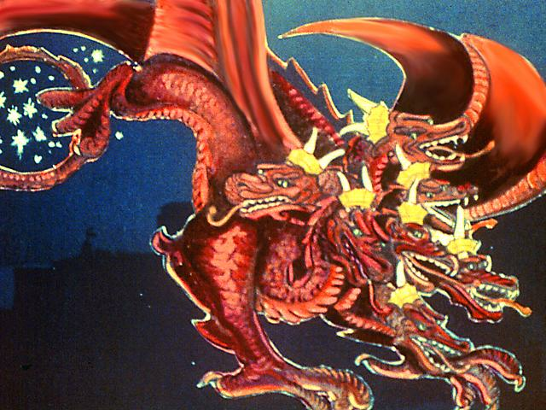
Revelation 12:3 And there appeared another wonder in heaven; and behold A GREAT RED DRAGON, having seven heads and ten horns, and seven crowns upon his heads.

Revelation 12:9 And THE GREAT DRAGON was cast out, that old serpent, called THE DEVIL, and Satan, which deceiveth the whole world: he was cast out into the earth, and his angels were cast out with him.

Here the dragon is identified as Satan. The seven heads and ten horns of the dragon symbolise Satan working through human agencies and powers. This is the devil's method of work - to use human instrumentalities. In Daniel 7 beasts and horns are shown to represent earthly powers. The twelfth chapter of Revelation pictures the age long conflict between Satan and the true church of God.

Revelation 12:2,4-5 And she BEING WITH CHILD cried, travailing in birth, and pained to be delivered... And his tail drew the third part of the stars of heaven, and did cast them to the earth: AND THE DRAGON STOOD BEFORE THE WOMAN which was ready to be delivered, for TO DEVOUR HER CHILD as soon as it was born. And she BROUGHT FORTH A MAN CHILD, who was to rule all nations with a rod of iron: and her child was CAUGHT UP UNTO GOD, and to his throne.

The church is figured as an expectant mother, who gives birth to a man child, who rules all nations, and is caught up to God's throne. Who is the man child? In Psalm 2:6-9 Christ, God’s son is revealed as the One who rules all nations with a rod of iron at His second coming. In these verses we see both the Old Testament church and Satan waiting for the birth of Christ. In verse 4 we see the devil's attempt to destroy Christ at birth.
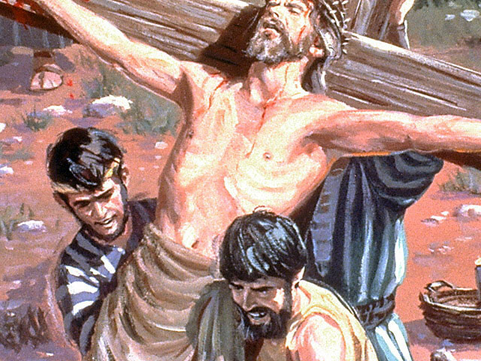
Matthew 2:16 Then HEROD, when he saw that he was mocked of the wise man, was exceeding wrath, and sent forth, and SLEW ALL THE CHILDREN THAT WERE IN BETHLEHEM, and in all the coasts thereof, FROM TWO YEARS OLD AND UNDER; according to the time that he had diligently enquired of the wise men.

Through Herod, a representative of the Pagan Roman Empire, Satan tried to put Christ to death. Eventually, the devil inspired wicked men to put Christ on the cross.

Acts 2:24 Whom God hath raised up, having LOOSED THE PAINS OF DEATH; because it WAS NOT POSSIBLE THAT HE SHOULD BE HOLDEN OF IT.

Death, however, could not devour Christ. He victoriously arose to life from the tomb. This parallels Revelation 12 verse 5, which states, Christ was caught up to God and to His throne.
Revelation 3:21 To him that overcometh will I grant to sit with me on my throne; even as I also overcame, and AM SET DOWN WITH MY FATHER IN HIS THRONE.

Christ fulfilled this when He ascended to heaven after His resurrection. The devil's attack on Christ failed, so he turned to attack Christ's church.

Revelation 12:13 And when the dragon saw that he was cast unto the earth, HE PERSECUTED THE WOMAN which brought forth the man child.
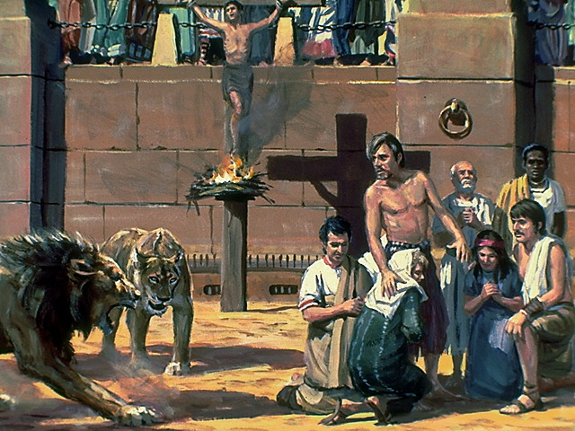

Violent persecution of the early Christian church followed, first by the Jews, then by the hand of pagan Rome, when two and a half million faithful followers of Jesus lost their lives because of their belief in the Saviour. However, this did not stop the church from flourishing. The martyrs' determination to be faithful to death, inspired others to join the church. The next strategy of Satan had the Pagan Romans praise the church, and even join it. The introduction of pagan principles began to undermine the pure faith of the Christian church, and there was a falling away from truth. In time the Papacy was set up, and the persecution of true Christianity was revitalised, even more bitterly than before.

Revelation 12:14,6 And TO THE WOMAN WERE GIVEN TWO WINGS of a great eagle, that she might FLY INTO THE WILDERNESS into her place, where she is nourished for a TIME AND TIMES, AND HALF A TIME, from the face of the serpent. And the woman fled into the wilderness, where she hath a place prepared of God, that they should feed her there A THOUSAND, TWO HUNDRED AND THREE SCORE DAYS.

The true church fled to uninhabited places to escape persecution. This persecution of small Christian groups by the Papacy continued for 1260 days, (or years - for a day equals a year in Bible prophecy). In the year 538 AD Justinian issued a decree that everyone within the empire must join the Catholic church within 90 days or leave the empire, and have his goods confiscated. This forced the faithful few to withdraw to the mountainous regions, to the shelter of valleys and caves for protection. The year 538 was the commencement of Papal supremacy. Adding on 1260 years brings us to 1798.
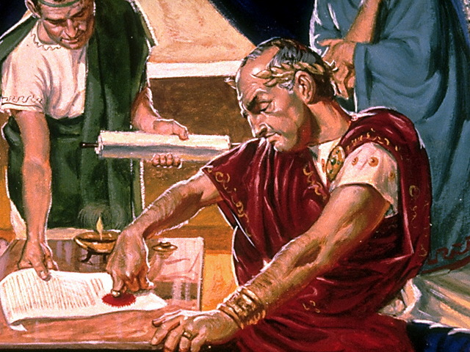
During the Dark Ages, God's true Church was outlawed from the great cities of apostate Christendom and driven into exile in "the wilderness". She was not found in Rome, Paris, Constantinople, or the other important centres of population, but in deserts, forests, caverns, and especially in the deep Alpine valleys of Central Europe. One of the best-known Christian communities to preserve a pure faith was the Waldenses, who, though cruelly persecuted, maintained their identity and faith for hundreds of years. They followed the Scriptures in simplicity, and refused to recognise the authority of the apostate Roman Church. Their own written confessions of faith, as well as the accusations of their enemies, bear witness to the remarkable purity of their lives and worship. History also records that similar companies of "Protestants", before the Reformation, were found in Southern France, the British Isles, Syria and Abyssinia. Satan launched a "flood" of Papal armies in Europe and Mohammedan hordes in the Middle East, in a furious effort to exterminate the fugitive Church. However, God provided miraculous protection, and "the earth helped the woman" in three remarkable ways:

Behind lofty mountain bulwarks, in caverns, valleys and forests. Through enlightened European rulers who befriended the Reformation. In the great American "New World" across the Atlantic.
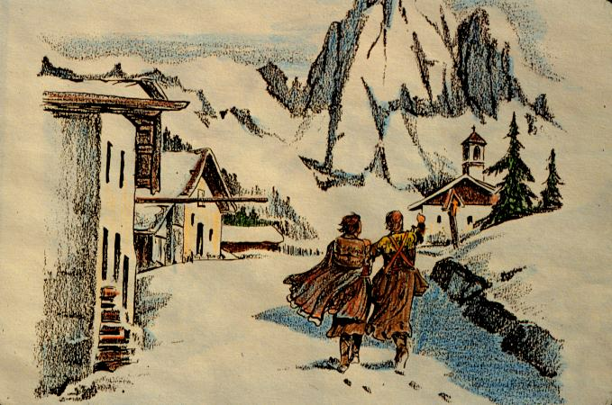

Thus in each generation of the Dark Ages, God preserved companies of faithful witnesses who are corporately represented by the fugitive woman. These heroic witnesses comprised "God's underground", who like the faithful 7,000 in Elijah's day, "refused to bow the knee to Baal"

These 1260 years coincide exactly with the 1260 years of Daniel 7, and Revelation 13. In the year 1798 the church and the state were separated in Italy. Napoleon dethroned the Pope, abolished his government, and religious freedom was given to all Italians. Thus Papal supremacy ceased in 1798. During these dark ages, no less than 150 million of the true people of God became martyrs, simply because they did not submit to the rule of Rome, but rather, upheld the Word of God as their guide in life.

Revelation 12:15,16 And the serpent cast out of his mouth water as a FLOOD AFTER THE WOMAN, that he might cause her to be carried away of the flood. And THE EARTH HELPED THE WOMAN, and the earth opened her mouth, and swallowed up the flood which the dragon cast out of his mouth.
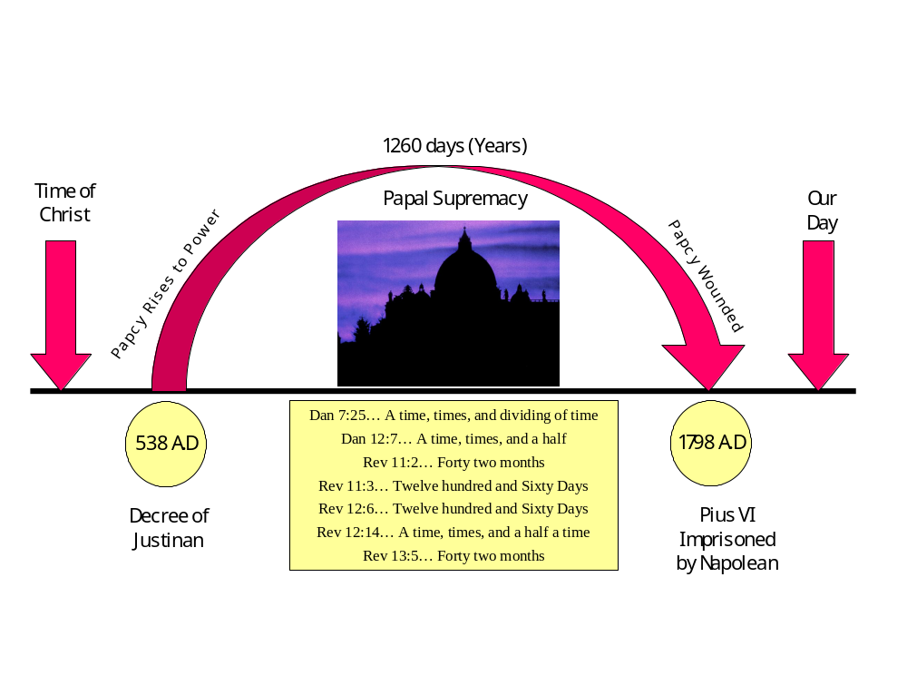

Waters, signifies peoples, nations and tongues, (see Revelation 17:15). Satan used nations, such as France and Spain, during the dark ages to exterminate God's faithful people. There were crusades and so called, holy wars organised to rid the earth of the faithful few. But the earth helped the woman. Natural hiding places in the mountains of Europe provided help for many who fled from Rome's persecutions, e.g. Piedmot Valleys in North Italy - where Waldensian believers were protected.

In France, "The Church of the Desert"; The Spanish Armada was destroyed by winds. Columbus discovered America and opened the new world to the persecuted. Thus the earth helped the woman. For 1260 years the True Church of God was bitterly persecuted, but not completely annihilated.
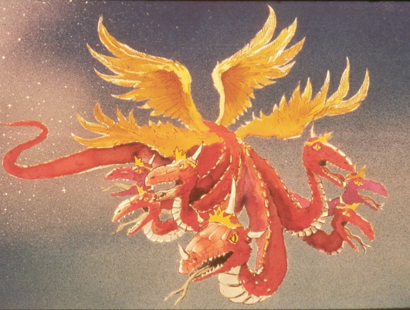

Revelation 12:17 And THE DRAGON WAS WRATH WITH THE WOMAN, and went to make WAR WITH THE REMNANT of her seed, which KEEP THE COMMANDMENTS OF GOD AND HAVE THE TESTIMONY OF JESUS CHRIST.

Here is the devil's final attempt to destroy God's truth. His attack is made against the "Remnant" or the last of God’s church. Here God's people are identified in the last days by the fact that they keep God's commandments and also have the testimony of Jesus. This is the vital identifying mark of the true church of God at the end of time. They will, in fact, be teaching the same truths as the Apostolic church. A remnant of material used for dressmaking etc. is the same pattern and colour as the original material in that bolt of cloth. So the remnant church will preach the same gospel truths taught by Jesus and the Apostles.

In summary, how do we ascertain which is God's true church today? Here are seven clear specifications:

1. A REMNANT = LAST PART. It will exist just prior to Christ's Coming.

2. A REMNANT = USUALLY SMALL. Truth is usually in the minority. So, God's last church will be small in number.

3. A REMNANT = SAME AS ORIGINAL. Identical teachings as Church of Apostles.

4. WOULD RISE AFTER 1798.
The remnant was not to arise before 1798 as the woman in the wilderness existed till then. In 1798 men began a diligent study of the Bible – particularly Daniel and Revelation, which led to the rise of the Seventh-Day Adventist Movement in 1844.


5. Revelation 12:17. Keep the commandments of God.

6. THUS IT IS A SABBATH-KEEPING CHURCH.(Isaiah 58:12,13)

- Revelation 12:17. HAS TESTIMONY OF JESUS.(Revelation 19:10)
SPIRIT OF PROPHECY.

The Seventh-day Adventist church fulfils these specifications. God has set up this movement, not to be another denomination, but to take the last warning message to the world. Many of God's faithful followers are in different churches, not knowing the full truth of the Bible. God uses His people wherever they are, but soon He is going to call His children into the fold. Revelation 18:2-4. Will you respond to the call of God to your heart and become one of the faithful remnant? God has a glorious future planned for His people, a future that will last forever. This He gives to those who are faithful, those who love Jesus and keep His commandments.

